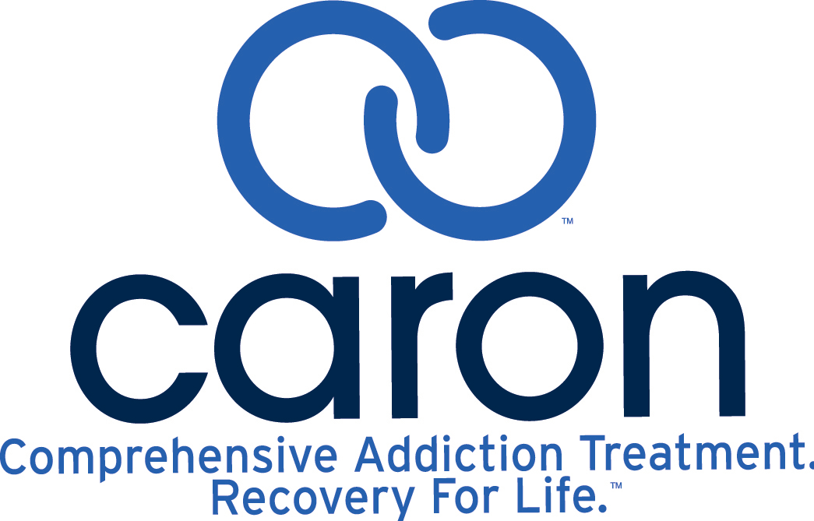

Valley Forge Middle School

STUDENT ASSISTANCE PROGRAM

**Parent Permission for Assessment**

Recently, your child has been referred to the Valley Forge Middle School CARE Team because he/she seems to be experiencing difficulty in school. As a part of this process, ____________________________ (student) has been recommended for a Comprehensive Behavioral Health Assessment by the Caron Treatment Centers.

---------------------------------------------------------------------------------------------------------------------

I understand that the Caron Treatment Centers will be providing an assessment for my son/daughter at no cost to me. I also understand that I will be informed of the determined level of care and suggested plan of action within 48 hours of the assessment by the Caron Treatment Centers representative. I also understand that the Caron Treatment Centers specialist is a liaison to the school district, and is not a school district employee.

In addition, I also understand that information gathered from the assessment will be given to the Grade Level Administrator for Tredyffrin-Easttown School District. This information will be confidential and will only be released to the Grade Level Administrator, who may share it with the appropriate personnel.

________________________________________ ___________________

Parent/Guardian Date

________________________________________ ___________________

SAP Team Member Date